

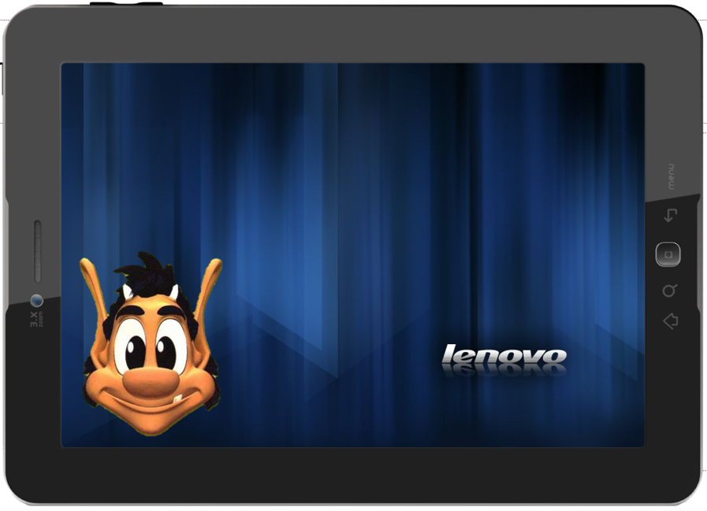

Ф.И.________________________________________ Ф.И.__________________________________

